**Sensors and Digitization Labratory no- 4 Report**

Center Universitaire Condorcet, University of Burgundy

MSc in MSCV

Alkan Omer Ozan

Daniel Sileshi Asfaw

November 16, 2013



**Compact Vision System**

**Objective:**

The objective of this laboratory was to study one compact machine vision system. Specifically, we practiced on the device how to:

* Detect *Edges* using the built-in device settings of CV-2100.
* Recognize *Patterns* from sample object scene.

**Equipments Used:**

* Controller unit (CV-2100)
* Remote control console (OP-42342)
* Monitor cable (RCA - RCA, 2 m)
* Camera (CV-020)
* CV-C3: Camera cable (3 m)
* Monitor CA-MN80
* 24 V DC power supply
* Backlight and objects for the seen

**Software Used:**

* Embedded KEYENCE Software

**Documentation used**

* High speed digital image sensor CV-2100 user manual

**Experiment-I: Edge Detection**

First we explored the user manual and we tried to familiarize ourselves with the setup and equipments.

In the first part of this experiment, we set up all the necessary accessories of High-speed Digital Image Sensor, CV-2100, and other equipments as shown in the following figure: Actually we used the implementation only for one camera.



For edge detection we grab an image after setting the camera to the following camera settings:

* Focus -0.4
* Aperture - 8

Using the "Edge pitch" measurement mode program, first target area is selected using a rectangular window shape (displayed in blue) and form this target we specify the specific area that we need to detect the edge as measurement area(displayed in white).

Finally we able to get the edges and the measurements.

**Results of this experimentation**

Edge Pitch

* Number of pitches: 3
* Upper limit: 2000
* Lower limit: 0

Gap

* Max val: 116.77
* Min val: 32.48
* Avg val: 86.73
* up limit:9999.9
* lo limit: 0.00

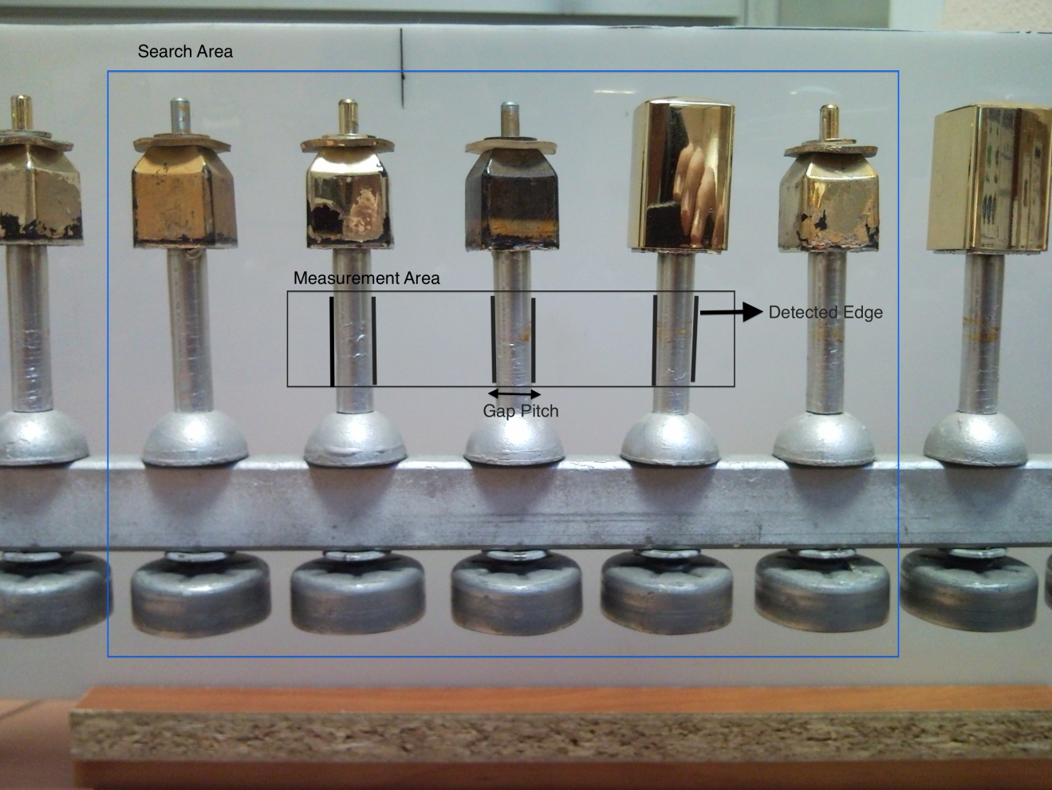

**Experiment-II: Caps Detection**

The goal of this experimentation was to find a pattern form from the given image. So we implement the pattern searching on a captured image.

Pattern search is selected form the windows setting first. Also we specified rectangular search area. We used our pattern area to be a rectangle. Finally, we are able to detect an object with rectangular shape from the captured image.

**Conclusion:**

In conclusion, in 2-hour lab, we achieved to detect edges with 'Edge Pitch' tools to measure the gaps between our tests objects. We also able to use 'Patter Search' tool to identify objects and detect objects in real time. This achievements with C++ or Matlab sounds impossible in 2 hours. Every Computer Vision professionals, for faster development, should consider so using this kind of embedded and compact systems. We learned our lesson that we should not always go for hard way, but should consider rapid development system. These tools are also good to experiment to see and get the results fast and in real time.